|  |  |
| --- | --- |
| www.ovm-kassel.de  |  LernJob  |  März 2010 |  |
| Lernjob AE-MS-1.3-E |  |
| **Code** | AE-MS-LJ-1.3-E |
| **Datum** | 24. März 2010 |
| **Links** |  |
| **Verwandte Lernjobs** |  |

**Nassi-Shneiderman Charts**

**Purpose**

Nassi-Shneiderman charts were developed by Nassi and Shneiderman as an alternative to traditional logic flowcharts. Their intention was to provide a structured, hierarchical, graphical view of the flow of logic through a program, a routine, a module, or a process. Nassi-Shneiderman charts are used to document, plan, and design detailed programming logic.

**Strengths, weaknesses, and limitations**

A properly prepared Nassi-Shneiderman chart can illustrate the flow of logic through a module or routine at a glance. Nassi-Shneiderman charts are useful for describing or planning relatively small modules, routines, or processes. They can be used to clearly show nesting and recursion, and are easily converted to structured code.

... . Traditional logic flowcharts ([# 55](http://www.hit.ac.il/staff/leonidM/information-systems/ch55.html)) are more familiar to most users and information system professionals. Algebra, pseudocode ([# 59](http://www.hit.ac.il/staff/leonidM/information-systems/ch59.html)), and structured English ([# 60](http://www.hit.ac.il/staff/leonidM/information-systems/ch60.html)) may be better choices for describing or planning algebraic algorithms with no decisions. ...

**DO WHILE loop**

There are two patterns for showing repetitive logic: DO WHILE and DO UNTIL (Fig. 1 shows a DO WHILE loop in the green block). In a DO WHILE block, the test is performed first and the associated instructions are performed only if (while) the test condition is true.

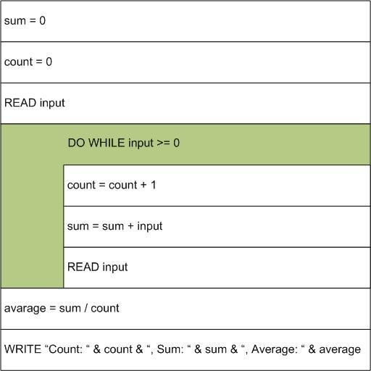

**Figure 1** Nassi-Shneiderman Chart for calculation the average of a sequence of input numbers.

In a DO UNTIL block, the associated instructions are executed first and then the exit condition is tested. Note that the logic block associated with a DO WHILE or DO UNTIL might represent one or more actual instructions [1].

|  |  |  |  |  |  |
| --- | --- | --- | --- | --- | --- |
| **Durchgang** | **sum** | **count** | **input** | **average** | **input>=0** |
| 1 | 0 | 0 | 15 | - | wahr |
|  | 15 | 1 | 21 | - | wahr |
| 2 | 36 | 2 | 3 | - | wahr |
| 3 |  |  |  |  |  |
| 4 |  |  |  |  |  |
| 5 |  |  |  |  |  |
|  |  |  |  |  |  |
|  |  |  |  |  |  |
|  |  |  |  |  |  |

**Tabelle 1** Schreibtischtest des Programms aus Fig. 1.

**Aufgabe**

* Übersetze den Text ins Deutsche. Erstelle eine Tabelle mit zwei Spalten. Kopiere den englischen Text in die linke Spalte und den deutschen Text in die rechte Spalte. Stelle die zusammengehörenden Sätze jeweils auf einer Höhe in der Tabelle dar.
* Führe einen Schreibtischtest für die folgenden Eingabewerte durch:   
  15, 21, 3, 12, 7, 16, 33, -6   
    
  Wie verändern sich die Variablen. Ergänze die Tabelle 1.
* Beschreibe in englischer Sprache, wie das Struktogramm in Figure. 1 umgebaut werden muss, wenn man mit einer „fussgesteuerten“ Schleife arbeiten möchte. Zeichne das veränderte Struktogramm.